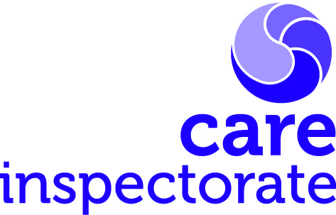
Joint inspections of services for children and young people at risk of harm

Post inspection questionnaire

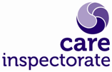Joint inspections of services for children and young people at risk of harm
Publication date: April 2024
Publication code 019

Post inspection questionnaire

Following the recent joint inspection of services for children and young people at risk of harm by the Care Inspectorate, Education Scotland, His Majesty's Inspectorate of Constabulary in Scotland and Healthcare Improvement Scotland, we would value your feedback. We will use this information to help us understand what works well and what could be improved in the current programme. We ask that you complete a single return from your partnership that represents the views of all relevant partners. To achieve this, we encourage you to consult with key people involved in the inspection before completing this form. Please use the text boxes to provide additional comments so we can take account of them as we continue to improve our approach.
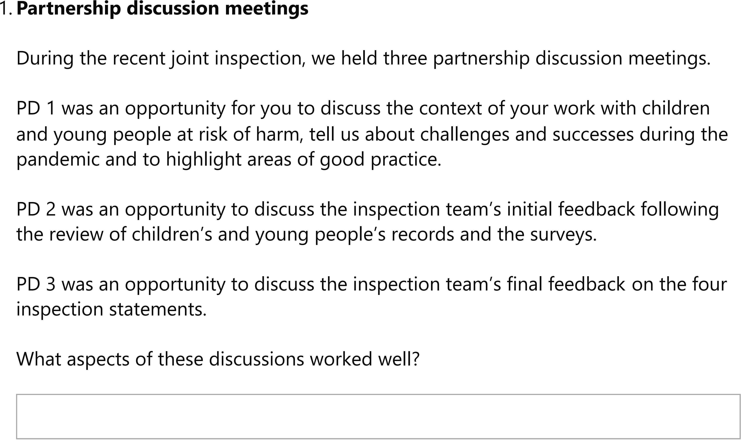
- What aspects of these discussions could be improved/done differently?

Co-ordination of evidence gathering
How well did we communicate with you about, and help you understand, our requirements in relation to:
- The record reading?

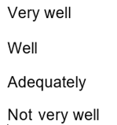

- Please give further comments

- The position statement and supplementary evidence?

- Please give further comments

- Arrangements to meet with children, young people and their families?

- Please give further comments

Methods
We used a variety of methods to gather evidence for the joint inspection. These include reading a sample of children's records, analysing the position statement and supporting evidence, analysing a staff survey, hearing directly from children, young people and families through a variety of engagement methods and meeting with staff and leaders.

- How effective do you think these activities were in helping us to understand the quality of your work with children and young people at risk of harm?
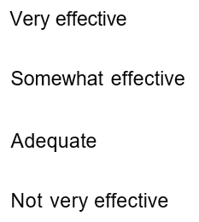
- Please give further comments

- How helpful were the overall findings in supporting your partnership to understand the difference your services make to the lives of children and young people at risk of harm?
- Please give further comments

Amplifying the voices of children and young people

- How well did we put the views and voices of children and young people at the heart of our joint inspection?

- Any other comments

- Please note any other comments you have which can support our review of the current joint inspection programme.

Headquarters
Care Inspectorate
Compass House
11 Riverside Drive
Dundee
DD1 4NY

web: www.careinspectorate.com
email: enquiries@careinspectorate.com
telephone: 0345 600 9527

@careinspect

Other languages and formats
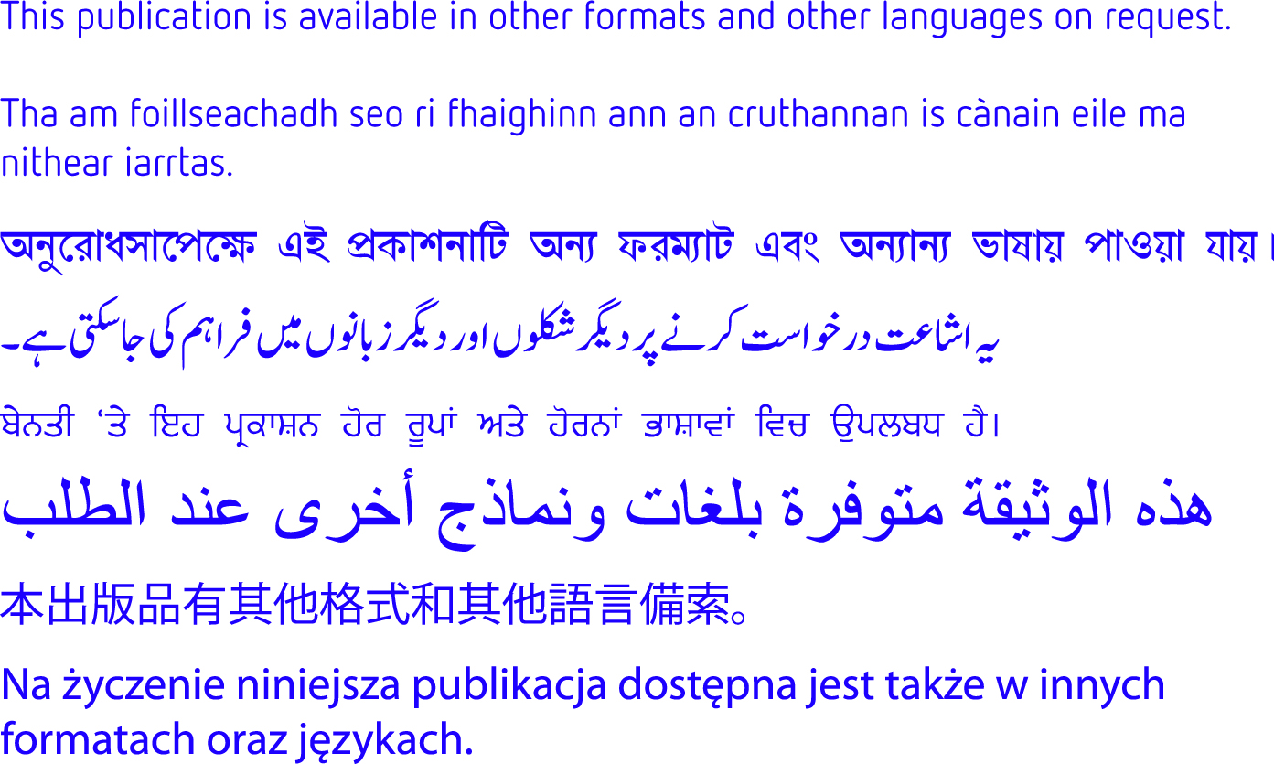

Copyright of Care Inspectorate 2024 