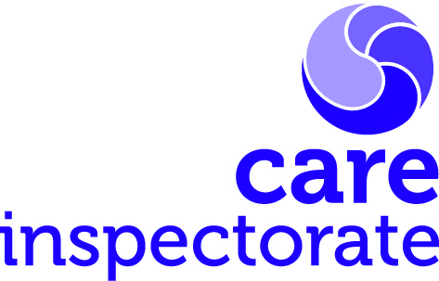
Joint inspections of services for children and young people at risk of harm

Selecting local records readers

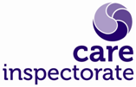Joint inspections of services for children and young people at risk of harm
Publication date: April 2024
Publication code 011
Involving local records readers in inspections of services for children and young people at risk of harm

The Care Inspectorate is fully committed to openness and transparency of the inspection process, supporting learning and dissemination of good practice across the country. We aim to work collaboratively with community planning partnerships (CPPs), building capacity and bringing added value to the scrutiny process wherever possible.
Where we are able to incorporate local practitioners or first line managers into our inspection programme to participate in reading children and young people’s records this will involve them in four days of records reading activity and a half day of training.
We will provide four hours of training for them beforehand. To help build capacity and bring added value to the community planning partnership, we can extend this opportunity to others with a quality assurance role to take part in this training day (up to 12 staff).
We ask that the partnership provides an anonymised child’s plan that can be used for training purposes. The plan should be recent (completed within the last 12 months) and include comprehensive assessment and plan. The child’s plan must not have been completed by anyone attending the training session.
From those who have been trained partnerships should identify four participants to be involved in the records reading activity, plus two reserves in the event that one of the four is unable to participate. This would provide greater opportunity for a wider range of stakeholders from statutory and third sector organisations to contribute to the inspection and develop their skills in multi-agency records reading. We aim to match each local records reader to an inspector for the duration of the record reading activity and to provide a higher degree of moderation and discussion to promote learning through this process.
Community planning partners should consider the following criteria when identifying potential local records readers from their services. These can be summarised in the table below:
Professional qualifications and experience  - Currently practising in a children’s services (statutory service or third sector organisation)  - Previous experience of case audit work within their own service  - Previous experience of taking part in multi-agency case audit work is helpful, but not essential  - Direct experience of managing or supervising child protection and/or looked after children casework | Personal aptitudes  - Good analytical skills  - Effective written communication skills; ability to write succinctly, simply and to use evaluative language  - IT skills – ability to use [excel]  - Ability to work independently

In recognition of the commitment given by chief officers to release local staff to take part in the records reading phase of the inspection, we recommend that on completion of their inspection experience, local records readers collectively prepare a short report for chief officers outlining their key learning and how this relates to aspects of service delivery with their own respective areas.
At a time when current challenges in respect of multi-agency case audits and data protection legislation (GDPR) can create barriers to this type of shared learning, we hope this approach offers the opportunity to build skills, capacity and knowledge across the local workforce. The inspection lead will be happy to discuss any aspects of involving local records readers with the key contact/co-ordinator at their first meeting.

Headquarters
Care Inspectorate
Compass House
11 Riverside Drive
Dundee
DD1 4NY

web: www.careinspectorate.com
email: enquiries@careinspectorate.com
telephone: 0345 600 9527

@careinspect

Other languages and formats

Copyright of Care Inspectorate 2024 