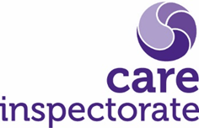

Self-evaluation tool guidance
Contents
Self-evaluation tool guidance 1
Introduction 1
Section one 3
Core assurances 3
Section two 3
The process 3
Section three 7
Evidence gathering for self-evaluation 7
Quality assurance activities 9
Quick win options 9
Improvement planning 11
Summary process 12
Links to templates and examples 13

Introduction
“Self-evaluation is where a service ‘systematically examines itself, achievements, and processes to assess whether it is meeting its stated objectives and outcomes efficiently and effectively’.”
Audit Scotland
The purpose of our self-evaluation tools is to support services to assess how well they are doing against the key questions from our quality framework and highlight areas where they need to support improved outcomes for people. This guide will help you to do that.
Self-evaluation can be a powerful tool to identify what’s working well and to identify and support improvement. We want all services to undertake self-evaluation. Self-evaluation is best done by those who know services, and includes people who use them, their relatives and staff. When we refer to people who use services, this includes children and their relatives.
This toolkit and guidance follow on from the work we have already undertaken in relation to self-evaluation and should be used along with the quality framework for your service type and our guide to self -evaluation. Self_evaluation_for_improvement_-_your_guide.pdf (careinspectorate.com)
This gives a suggested step by step guide and information on:
• what self-evaluation is
• how to use self-evaluation
• carrying out your self-evaluation
• involving people who experience care and their carers.
The quality frameworks are primarily designed to support services with self-evaluation. We worked with the services we regulate to build capacity for self-evaluation based on the frameworks. Quality framework for ELC services (careinspectorate.com)
Self-evaluation is not done for our benefit. It is a process that your service leads on, so you should determine the frequency and focus of your self-evaluation. Well-led services know where they are performing well, and where they need to improve. You should use self-evaluation to inform where you need to target your efforts to support improvement. It is an ongoing process which supports continuous improvement, rather than being a one-off activity.
Some services already have well-established and effective processes for evaluating their performance, and they should continue to use them. We are not asking all services to use this tool, as other tools are available, however, we do want all services to recognise the value that self-evaluation has in supporting improvement and better outcomes for people. Whichever tool you use, it should be linked to the quality framework for your service type and the Health and Social Care Standards, which set out what people should expect when using health, social care or social work services in Scotland. If you are already using ‘How good is our early learning and childcare’ this document shows how these frameworks link to each other. How the framework links to How good is our early learning and childcare (careinspectorate.com)
This guide describes a process that can complement what you already do and gives advice and ideas about how existing processes can be used effectively. It embeds self-evaluation in the quality frameworks and will support you to evaluate your service.
We recognise that services are under significant pressure and have needed to adapt and do things differently.
On page 9 we have suggested some ‘quick win options’ to identify more immediate areas for improvement through self-evaluation that offer some alternative, short-term solutions and consider barriers that may be in place. This makes it easier to get started with self-evaluation and make improvements, even if you can only carry out elements of the process.

Section one

Core assurances
Experience has taught us that when things go wrong in care services, they often relate to key areas. Theory and inquiries into when care goes wrong have highlighted the areas that are important to monitor because these can be identified as early indicators of concern to people using services (Scottish Government 2014, Hull University 2012, Francis Report 2013, Wardhaugh and Wilding 1993).
These are the key areas considered during the registration process, and policies and procedures relating to them must be in place before a service is registered. Because we know, and research tells us, that these key areas are essential to a service being safe, we have called them ‘core assurances.’
This checklist of core assurances highlights what inspectors must look at on inspection. They help guide providers on the areas that are important to people’s safety and wellbeing. The core assurances span the entire framework, covering elements of several different quality indicators.
The list of core assurances can be found in this toolkit and includes a worked example, to help you check that you are meeting all these core assurances and are able to evidence this.

Section two

The process

This self-evaluation tool is based around the key areas from our quality frameworks. The key areas sit under each quality indicator as shown below.
Key question 1: How good is our care, play and learning?
Quality indicator | 1.1 Nurturing care and support
Key areas | - Children are nurtured and supported throughout their daily experience  - Children’s individual wellbeing benefits from the effective use of personal planning  - All children get the support they need to reach their full potential

We want you to ask three self-evaluation questions for each key area:
• how are we doing?
• how do we know?
• what are we going to do now?
Each key area has several quality illustrations which can provide a benchmark and guide to what you should look at when evaluating how well your service is performing.
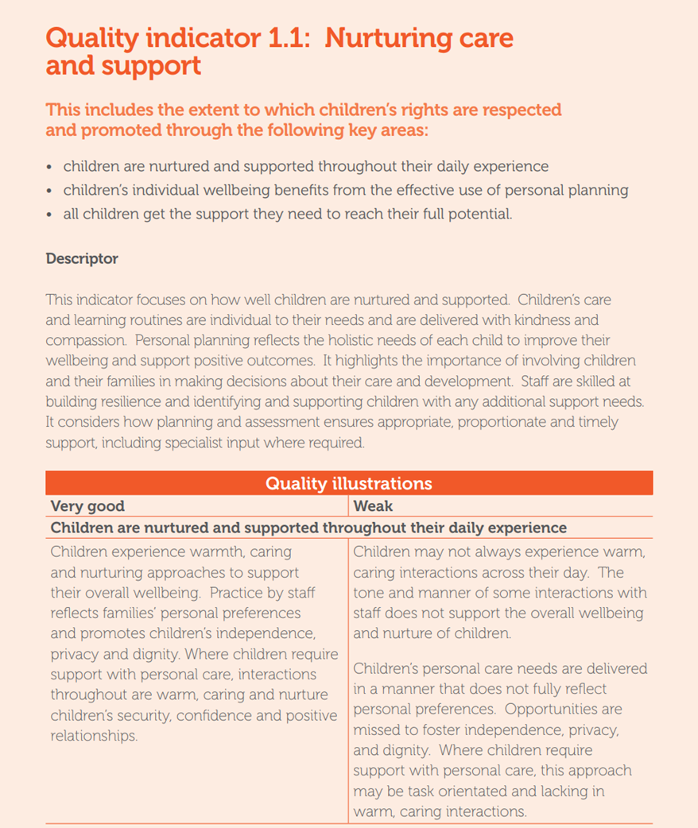
Quality Illustrations
Descriptor
Key areas
Quality indicator

After each quality indicator, there will be links to related best practice guidance documents under the key improvement resources section.
You will find links to worked examples at the end of this guide, showing how you could complete one of these key areas with some of the ways you could identify, connect, and evaluate your evidence. By the end of this process, you will have evaluated your service and will be able to develop an improvement plan.

The three self-evaluation questions
When carrying out your self-evaluation you should ask these three questions about each key area.
1. How are we doing?
2. How do we know?
3. What are we going to do now?

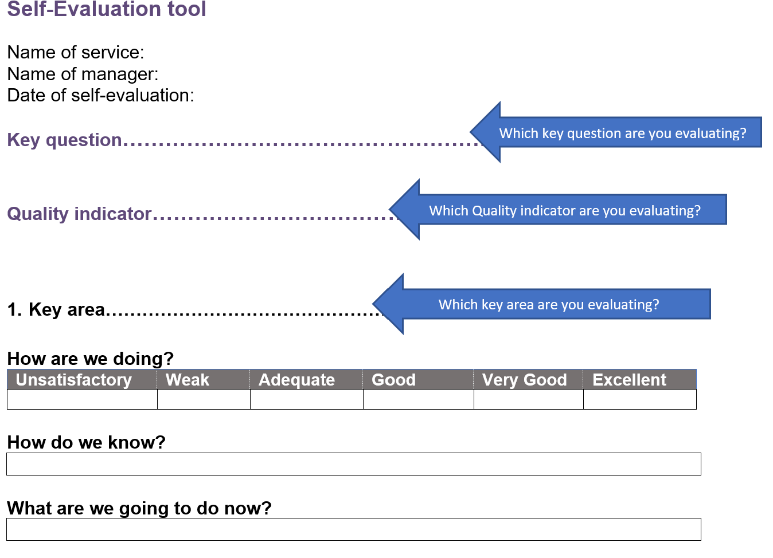
Question 1 - How are we doing?
This is the key to knowing whether you are doing the right things in the right way and whether, as a result, people are experiencing high-quality, safe and compassionate care that meets their needs, rights and choices. You can use good practice guides and the quality illustrations to make sure you are asking the right questions.
Unsatisfactory | Weak | Adequate | Good | Very good | Excellent

These evaluations are based on our six-point scale. Further information about each of these evaluations can be found within the quality frameworks and on our website here. Quality grades (careinspectorate.com)
This description should be easily understood by those who use your service, staff and relatives. Evaluate how your service is performing for each of the key areas in each of the key questions, using the above scale. Your evidence should include:
• feedback from staff, people using the service, relatives and other stakeholders
• observations of staff practice
• quality assurance activities
• benchmarking against good practice and the quality illustrations.
There is more detailed guidance including examples in ‘Section 2, evidence gathering’ on page 7.

Question 2 - How do we know?
How have you arrived at your answer to Question 1 ‘How are we doing?’ Answer this question using evaluative statements, based on the evidence you have gathered.
You should use the quality illustrations within the framework, the Health and Social Care Standards and good practice documents as benchmarks, which may also help you think about where improvements need to be made.
Look at the scrutiny actions and improvement resources in the quality framework to see some examples of where you may find other sources of evidence or good practice.

Question 3 - What are we going to do now?
Understanding how well your service is performing should help you see what is working well and what needs to be improved. From that, you should be able to develop and prioritise plans for improvement based on effective practice, guidance, research, testing, and available improvement support. The ability to identify what is not working well, where improvements need to be made and developing a plan to address these is a strength. It demonstrates good leadership and management and is characteristic of an organisation that is committed to learning and developing to support the best outcomes for people.
By the end of the questions, you should be able to write your improvement plan. By answering each of the three questions you will have identified where your service is doing well and where you need to improve to support better outcomes for people using your service.
The improvement plan should include:
• the actions
• who will carry them out
• a timetable
• a review of what was achieved or where further action is required.
This tool should be used as part of your service’s normal participation and quality assurance work. Remember, you are not undertaking this for the Care Inspectorate. You are doing this to help improve outcomes for people using your service. Where our scrutiny activities show us that a service has used self-evaluation to identify and plan to address areas for improvement, we would usually regard this as a management strength. Where we identify areas for improvement that you are not aware of, or for which there is no improvement plan in place, this is likely to affect the evaluations we make.

Section three

Evidence gathering for self-evaluation

Aim: to enable people to give their view on how the service is performing in a range of different areas in a measured way.

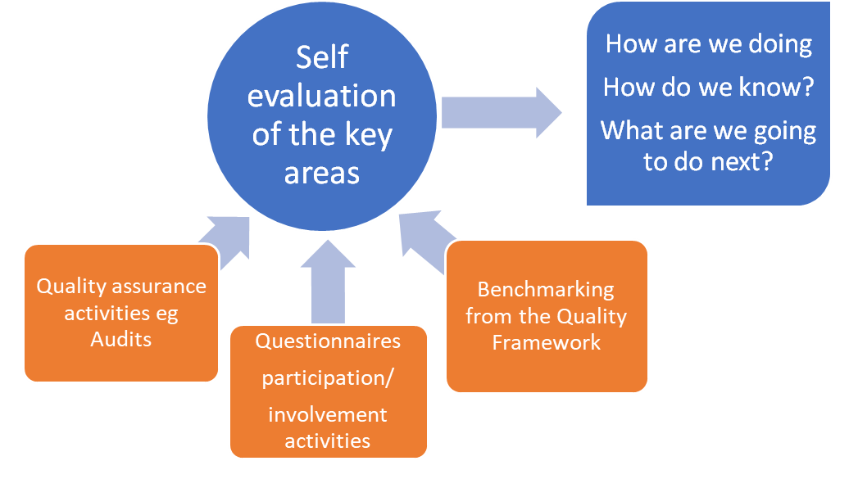

When gathering evidence as part of your self-evaluation, you will need to involve staff and the people using the service, including those important to them. Some of this evidence could include questionnaires, but there are other means of consulting with people that you might also want to consider, including focus groups or simply taking the time to talk to people to get their views on specific issues. You should take different communication needs into account and use any appropriate communication tools when consulting with people using the service. There is some helpful advice on different communication aids available here. Communication Aids | AbilityNet

By asking people to evaluate an area using a scale, you can measure how you are doing in a more systematic way. By repeating these questions, and the process at a later date, you will be able to measure your progress. Breaking down the key areas for self-evaluation into smaller, more specific questions will help you build a picture of how you are performing across the whole key area.
Example
‘In September 2019 we found that only 25% of people felt that communication with the service was good. This was identified as an area where we needed to make improvements and incorporated it into our action plan. We decided to provide a monthly newsletter for parents and carers, and we increased our use of social media and our digital app so that we could make sure that people using the service were kept up to date with what was happening in the service. In April 2020 we completed the self-evaluation again and this time we found that 80% of people felt that communication was either good or very good. This showed us the impact that the improvement activities had made to people.

At the end of this document, we have provided links to templates for questionnaires, with examples of questions that may be useful to elicit feedback under each of the key areas. The questionnaires are based on the illustrations in the framework. We would suggest getting feedback from people who use the service, relatives and carers, staff and other stakeholders, such as visiting professionals, or those with regular input to the service. People should have the option to remain anonymous or give their details if they would like a response to any comments or issues they have raised. You should also set a clear deadline for responses and offer alternative ways for people to respond or receive information, for example through email, post or in person. You should tailor these questions so that they suit your service.
There is no expectation that you would use all these questions in one questionnaire as they are suggestions which may help you focus on areas you have decided to focus on. This includes making adjustments to how the questions are presented to support communication, for example using talking mats, pictures or symbols.
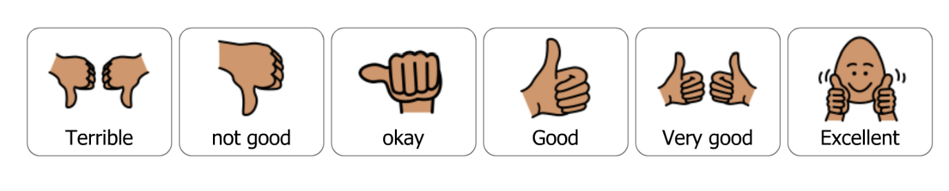
Image: https://goboardmaker.com/

These questionnaires are only one way of gaining feedback, you could consider things such as focus groups, team meetings or service events as opportunities to gather feedback. You should also consider how you will receive feedback directly from children. For older children this might be through games and activities or by completing floor books and recording children’s comments. For younger children you may wish to consider using observations of their play and learning, which could be part of your usual quality assurance activities.
Eurochild has a helpful participation toolkit that may help you to increase children’s participation in self-evaluation. https://eurochild.org/uploads/2021/01/We_Are_Here_Toolbox.pdf

Quality assurance activities

Aim: To check quality and provide more robust evidence about performance across key areas of the service.
There are a number of quality assurance activities that can contribute to your self-evaluation. You should have in place different processes and systems to ensure good care and support for people, and these can be used to inform your self-evaluation.
Key question 3 ‘How good is our leadership’ in the quality frameworks talk more about quality assurance with examples of what very good (and weak) practice may look like and where you can find more information. Ways of assuring quality include using audits and observations of staff practice.
Your quality assurance processes should help you identify areas for improvement, as well as areas that are working well. This information can then feed into the self-evaluation as evidence for your assessments of where you are at.
Example
If you are looking at how well you are performing in relation to keeping children safe on trips. You could use the ‘Keeping Children Safe’ guidance from our HUB as a benchmark. You may have already audited training, was this identified as a priority? Did staff attend any training you have provided, is this discussed during supervision/team meetings to check understanding? Have you completed observations of staff practice, did they follow the guidance? Have you identified any practice concerns?

Quick win options

In order for the self-evaluation process to be meaningful and useful, the same general process should be followed. We appreciate that services may struggle with the idea of something new being introduced at this point in time. With that in mind, we have suggested a summary version of the process that will support those who have extremely limited capacity but will still offer some of the benefits of undertaking the process.
This is a temporary option as way of engaging with the process and beginning an improvement journey, with the expectation that this is a starting point only.

Barriers
- I don’t have time to send out questionnaires to family members and there are working parents who don’t have time to complete surveys or take part in focus groups.
- I don’t have the resources to support people using the service to complete questionnaires or hold focus groups.
- I don’t have time to send out and collate all that information because this is a large service, and we are already short staffed.
- We haven’t been carrying out our usual quality assurance processes due to being short staffed.
- People using the service / relatives are unhappy with aspects of the service which are out with our control, for instance, access to the service rules, government restrictions.
- The self-evaluation is too much work, I don’t have time to do this
- Parents don’t have time to do this – they have busy lives and are rushing around to get their child to the next activity.
- I don’t have time to do this because there is already too much paperwork and I don’t get enough time with my family as it is.
- I’m a childminder not a nursery.
- It is difficult to carry out meaningful participation activities with children, especially those who are very young. Relationships can be key as staff caring for children may be more attuned to their needs and wishes.
Alternatives
- Prioritise the completion of the core assurances as this will help highlight any key issues and areas for concern.
- Focus on one key area at a time, they don’t have to all be completed together.
- Use your existing governance and quality assurance systems to monitor the standards of care.
- If there is an issue you already know about within the service, try using the format of the self-evaluation to address it. For example, answering the second and third questions: ‘How do we know?’, how did the issue come to your attention), and ‘What are we going to do now?’, how are you going to address the problem? You can start an improvement plan from here just filling in the boxes with the information you already have.
- Use information you already have. You may have recently completed involvement activities, received feedback from relatives, stakeholders or people using the service. There may have been recent audits or incidents where key information has come to light that needs addressing, for instance, drop off and collection procedures to ensure children’s safety or the need for key information in personal plans to be updated.
- Leave a pile of questionnaires and a feedback box out for staff over the course of a week or two weeks (in line with current infection control guidance). Use voting jars/tokens, question of the week on whatsapp
- Email all staff a questionnaire and set up a shared file where completed questionnaires can be saved into. Set a deadline.
- Set up an electronic survey using a software platform such as Survey Monkey or Microsoft forms, which can also collate responses for you.
- During the normal course of your day, take time to ask people using the service who you come into contact with some simple questions relevant to the key area you are looking at (use examples from the questionnaires). Just remember to ask people the same thing and make a note of what you asked them for future reference. You can also do this if you have visitors to the service, including stakeholders.
- Build participation activities for children into your daily routines, whilst ensuring this doesn’t unnecessarily interrupt children’s play and they can choose not to take part if they wish.

Improvement planning

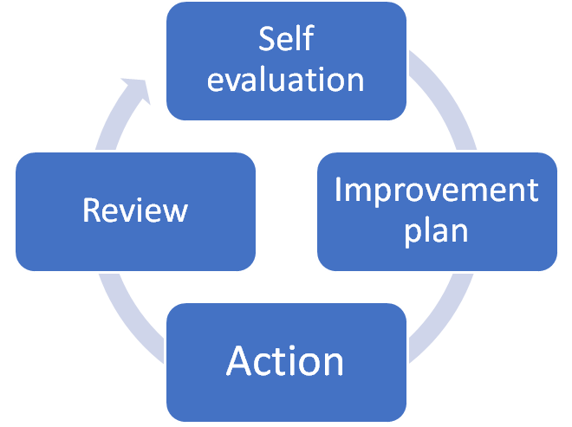

Improvement planning is part of the wider self-evaluation and quality assurance cycle. These are not one-off activities and in order to identify what improvements are required and what improvement actions are working, there needs to be ongoing self-evaluation and review. The timescales for this are up to your individual service and depend on where you are in your improvement journey. For services needing to make a number of improvements that are essential to improving outcomes for people, more regular reviews would be required to ensure that the service continues to move forward, and changes can be made where things are not working.
All our quality frameworks include a key question that evaluates ‘how good is our leadership’. This key question recognises the importance of good quality assurance and improvement activities, including:
• quality assurance, including self-evaluation and improvement plans, drive change and improvement where necessary
• leaders are responsive to feedback and use learning to improve
• leaders have the skills and capacity to oversee improvement.
Our guide to self-evaluation directs you to other resources, such as our Model for Improvement, and gives more information on the process of planning improvements. How we support improvement | Care Inspectorate Hub

Summary process
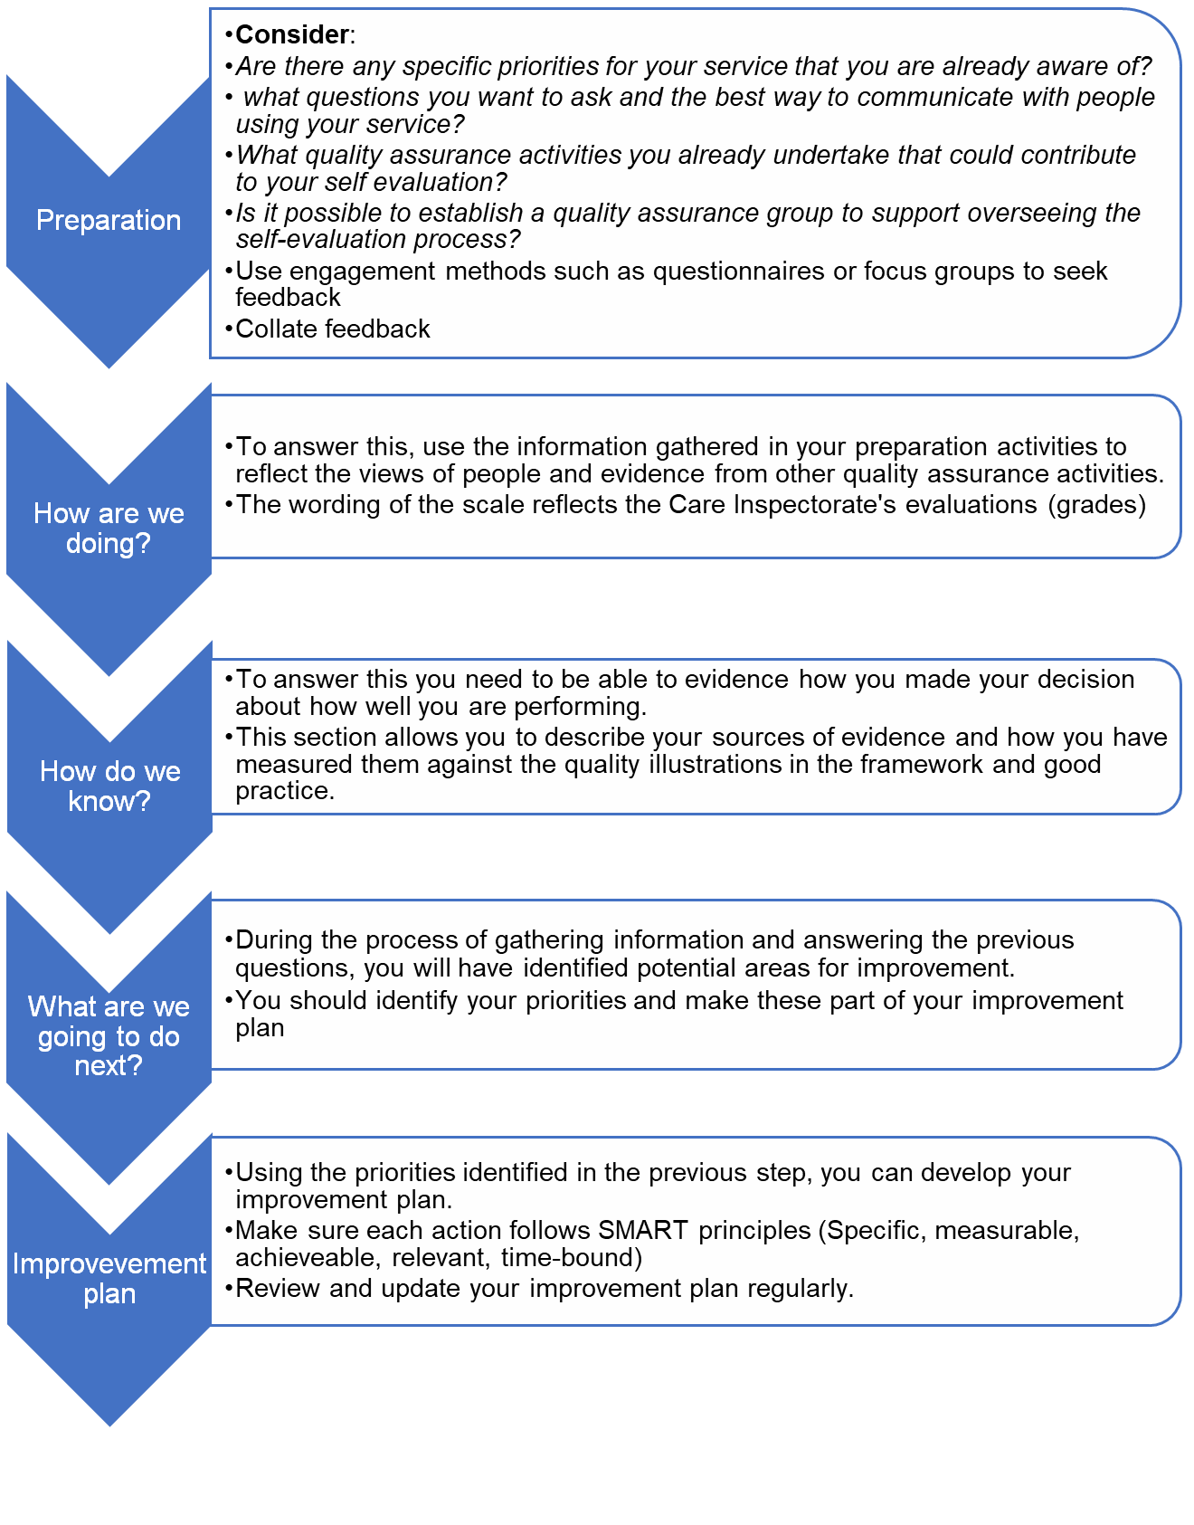

Links to templates and examples (these will be added when we put the documents on the website)
Core assurances (worked example and tool)
Example questionnaires for:
Children
Relatives
Staff
Visiting professionals / stakeholders (not childminders)
Improvement plan template
Self-evaluation tool template
Worked example

The Stationery Office. Hull University (2012).
Early indicators of concern in residential and nursing homes for older people. Centre for Applied Research and Evaluation.
University of Hull Available at: http://www.bsab.org/media/Hull_Report_2012.pdf Scottish Government (2014).
Headquarters Care Inspectorate Compass House 11 Riverside Drive Dundee DD1 4NY web: www.careinspectorate.com email: enquiries@careinspectorate.com telephone: 0345 600 9527 @careinspect Copyright of Care Inspectorate 2022

